STUDENT PERFORMANCE ANALYSIS SYSTEM
Srija Akula  Department of Computer Science and Engineering  KL University  Bachupally, Hyderabad, India  University ID: 2420030062 | I. Srivalli  Department of Computer Science and Engineering  KL University  Bachupally, Hyderabad, India  University ID: 2420030742 | Dr. N. Sunanda  Department of Computer Science and Engineering  KL University  Bachupally, Hyderabad, India

Abstract—Student academic performance is influenced by academic, demographic, family, social, and behavioural factors. Educational institutions collect these records, but interpreting large tables manually can make it difficult to identify grade patterns and relationships among student attributes. This paper presents a Student Performance Analysis System that applies exploratory data analysis and visualization to student academic records. The project uses the student-mat.csv dataset from the UCI Machine Learning Repository, representing mathematics-course records from Portuguese secondary schools. The dataset contains 395 student records and 33 attributes, including period grades G1 and G2, final grade G3, study time, past class failures, absences, family support, and school support. Python is used for data processing, Pandas and NumPy support data inspection and numerical operations, and Matplotlib and Seaborn generate visual summaries. A Streamlit dashboard provides an interactive interface for examining grade distributions, comparing performance across selected attributes, and exploring relationships among numerical variables. The paper reviews more than fifteen research studies in educational data mining, student performance analysis, and learning analytics. The proposed system is exploratory and descriptive; it does not claim to predict future grades or establish causal relationships. The project demonstrates how a structured data-science workflow can make academic records easier to inspect and discuss.
Index Terms—Student Performance, Educational Data Mining, Exploratory Data Analysis, Academic Analytics, Python, Data Visualization, Streamlit.

I. INTRODUCTION
Educational institutions maintain academic records to monitor student progress, evaluate learning outcomes, and understand areas where additional academic support may be useful. These records may include examination grades, attendance, study habits, family background, school-related support, and other contextual attributes. When information is stored only in spreadsheets, identifying patterns across multiple variables can be time-consuming. A structured analysis system can organize these records and present information through summaries and visual representations.
Student performance is multi-dimensional. Previous assessment grades may be associated with later results, while study time, past class failures, absences, family support, and school support provide additional context. Such attributes should be interpreted carefully: an association between a variable and a grade does not prove that the variable causes a change in academic performance. Exploratory Data Analysis (EDA) provides a practical first step by examining data types, distributions, missing values, summary statistics, and relationships before advanced modelling is considered.
The proposed Student Performance Analysis System focuses on descriptive analysis and visualization rather than automated prediction. It loads the mathematics dataset, checks and prepares the records, calculates descriptive summaries, and presents selected views through a Streamlit dashboard. The interface helps users inspect grade patterns and compare groups without manually generating separate charts from the source CSV file.
The main contributions are: (1) a repeatable workflow for loading and inspecting student data; (2) preprocessing of academic and student-related attributes; (3) descriptive analysis of G1, G2, and G3 grades; (4) visual comparison of performance patterns across selected attributes; and (5) an interactive dashboard for presenting the analysis. The system is an academic analysis tool and is not a replacement for teacher judgement or formal student evaluation.
II. RELATED WORK
Romero and Ventura [1] reviewed the state of educational data mining and explained how data mining techniques can be applied to educational databases to understand learner behaviour and academic outcomes. Their review provides a foundation for systems that transform student records into interpretable information. The present project applies this principle through descriptive summaries and visual analysis rather than predictive modelling.
Baker and Yacef [2] discussed the development of educational data mining as a research field and highlighted its relationship with learning analytics. Their work emphasizes extracting useful patterns from educational data while considering the learning context. This supports the project's focus on examining academic records together with student-related attributes.
Cortez and Silva [3] introduced student achievement datasets from two Portuguese secondary schools and investigated data-mining approaches for predicting student performance. The mathematics dataset used in this project is part of this collection. It contains grade variables and demographic, social, and school-related attributes, making it suitable for exploratory comparisons as well as prediction-oriented research.
Asif et al. [4] analysed undergraduate student performance using educational data mining. Their study examined academic achievement over a four-year programme and explored typical student progressions. The authors showed how patterns in selected courses can help distinguish student progress profiles and support timely academic guidance.
Abu Saa, Al-Emran, and Shaalan [5] reviewed factors affecting student performance in higher education. They grouped commonly studied variables into previous academic performance, e-learning activity, demographic information, and social information. Their review indicates that student achievement should not be understood through examination marks alone. The present system similarly examines grades alongside study habits, family support, school support, and other available attributes.
Alyahyan and Düştegör [6] reviewed research on predicting academic success in higher education and discussed best practices for identifying students who may be at risk. Their work highlights the need to consider the timing of prediction, the quality of input data, and the practical meaning of the outcome. The present project adopts a more limited descriptive scope and avoids presenting visual comparisons as predictions.
Namoun and Alshanqiti [7] conducted a systematic literature review of student performance prediction using data mining and learning analytics. They analysed studies from 2010 to 2020 and discussed learning outcomes, predictive models, and factors associated with student achievement. Their findings reinforce the importance of academic assessment data and student learning activity in educational analysis.
Khan and Ghosh [8] reviewed educational data mining studies focused specifically on student performance in classroom learning. Their review covered 140 studies and considered predictors, methods, and the timing of performance analysis. The study is relevant because it distinguishes classroom-based evidence from online-learning activity data.
Zhang et al. [9] reviewed educational data mining techniques for student performance prediction and compared stages involved in data collection, problem formulation, modelling, prediction, and application. Their review provides a structured view of predictive research. The current system concentrates on initial data inspection and descriptive analysis before any predictive model is considered.
López-Zambrano, Lara Torralbo, and Romero [10] presented a systematic review of early prediction of student learning performance through data mining. They examined 82 studies and discussed educational settings, data mining techniques, input variables, and timing of prediction. Their findings identify assessment information and learning-system interaction as commonly used features. The present project instead uses attributes available in the UCI mathematics dataset.
Hussain et al. [11] studied student engagement in an e-learning system and its relationship with course assessment scores. Their work used activity information from a virtual learning environment and developed a dashboard to support instructors. This demonstrates how visualization can make educational analytics more actionable. The present project uses a static CSV dataset and does not analyse online activity logs.
Roslan and Chen [12] reviewed educational data mining research published between 2015 and 2021. Their review found that student academic records and demographic attributes were frequently used, while classification and decision-tree approaches were common in prediction studies. This supports combining academic and contextual attributes, while the present project remains focused on exploratory visual analysis.
Yağcı [13] compared machine-learning algorithms for predicting undergraduate final examination grades using midterm grades and academic-unit information. The study used records from 1,854 students and reported that earlier assessment grades can be informative for final outcomes. This is related to the G1, G2, and G3 variables in the selected dataset, although the current project only describes their distributions and relationships.
Chaka [14] synthesized review studies on educational data mining methods, algorithms, and tools for predicting academic performance. The overview identifies recurring research approaches and highlights the variety of data sources and techniques used in this domain. It provides broader context for the present system's choice of a lightweight Python-based analysis workflow.
Alwarthan et al. [15] reviewed data-mining approaches for predicting student academic performance in higher education. Their study discusses how educational datasets can support the identification of patterns relevant to student success. The present project shares the general goal of making academic data easier to interpret, but does not implement a predictive model or make intervention decisions.
Altujjar et al. [16] investigated critical courses that influence student performance using decision-tree analysis. Their case study demonstrates that performance in selected courses can provide useful information about later academic outcomes. The present project similarly enables comparisons among available student attributes, while avoiding claims that any single attribute determines final grades.
Romero et al. [17] examined the prediction of students' final performance from participation in online discussion forums. Their study considered forum participation as an educational activity that can provide information about student understanding. This work shows the value of behavioural data, whereas the present system is limited to academic, demographic, and social attributes in student-mat.csv.
Santos and Henriques [18] investigated course-agnostic early prediction of student performance using learning-management-system logs. Their research considered whether models trained on activity data could generalize across courses and institutions. It illustrates the potential of longitudinal digital learning records. The present project does not have LMS logs and restricts its analysis to the supplied mathematics records.
Khairy et al. [19] studied student examination performance using data-mining classification algorithms and undergraduate academic records. Their work reflects the continuing use of classification techniques to examine academic outcomes. In contrast, the proposed system emphasizes descriptive statistics and visual comparison, providing an accessible first layer of analysis before any classification task is attempted.
The reviewed literature establishes three recurring themes: academic grades are important indicators of achievement; contextual and behavioural attributes can add useful information; and visualization can make educational records easier to interpret. The gap addressed by this project is practical and implementation-oriented: a compact, reproducible workflow that inspects a public student dataset and presents descriptive patterns through a simple dashboard. Unlike prediction-focused studies, this project does not report model accuracy or claim to identify future academic outcomes.
III. DATASET AND METHODOLOGY
A. Dataset Description
The project uses the student-mat.csv file associated with the Student Performance dataset available through the UCI Machine Learning Repository [20]. The dataset represents mathematics-course records from Portuguese secondary schools. The commonly distributed mathematics file contains 395 student records and 33 attributes. It includes school and demographic information, family and school support, study time, past class failures, absences, and grades from three assessment periods.
The grade attributes are G1 (first-period grade), G2 (second-period grade), and G3 (final grade). Other attributes include age, sex, address type, parental education, studytime, failures, schoolsup, famsup, internet, absences, and health. The dataset is historical and specific to the participating Portuguese schools; its observations should not be treated as representative of all current students or institutions.
B. Tools and Technologies
Python is used as the primary programming language. Pandas supports CSV loading, filtering, grouping, and summary calculations. NumPy supports numerical operations. Matplotlib and Seaborn generate histograms, count plots, bar charts, box plots, and correlation heatmaps where appropriate. Streamlit provides the dashboard interface and allows users to navigate analytical views without working directly with the source code.
C. Data Preprocessing
The preprocessing stage begins by loading the CSV file into a Pandas DataFrame. The data structure is inspected using row samples, column names, data types, and summary information. Missing values are checked column-wise, and duplicate records are examined before analysis. Categorical and numerical columns are handled according to their data types. Where a chart or calculation requires numerical values, the relevant columns are selected or converted carefully. Missing observations are not automatically replaced with arbitrary values; each analysis uses an appropriate treatment and reports valid observation counts when necessary.
D. Exploratory Data Analysis
EDA is performed to understand the distribution of student grades and the variation in student-related attributes. Descriptive statistics such as count, mean, standard deviation, minimum, median, and maximum are used for numerical fields. Frequency counts summarize categorical attributes. Grade distributions help identify the spread of G1, G2, and G3, while comparisons across selected categories can reveal differences among the observed groups.
Histograms show numerical grade distributions; bar charts compare category counts or average grades; box plots display spread and possible outliers across groups; and correlation heatmaps summarize pairwise linear relationships among numerical attributes. Correlation is descriptive and does not establish that one attribute causes a change in academic performance.
E. System Workflow
The system follows these stages: dataset selection, CSV loading, data inspection, preprocessing, exploratory analysis, chart generation, and dashboard presentation. Users can select available views or filters in the Streamlit interface and inspect the corresponding summaries. The workflow is designed to be reproducible using the same dataset and documented preprocessing steps.
IV. SYSTEM ARCHITECTURE
The system architecture consists of six logical layers. The dataset layer stores the student-mat.csv file. The data-loading layer reads the file into a Pandas DataFrame. The preprocessing layer checks the structure, data types, missing observations, and duplicate records before preparing the data for analysis. The analysis layer performs descriptive statistics, grade comparisons, attribute-wise summaries, and correlation analysis. The visualization layer generates charts using Matplotlib and Seaborn. Finally, the presentation layer displays the outputs through the Streamlit dashboard.
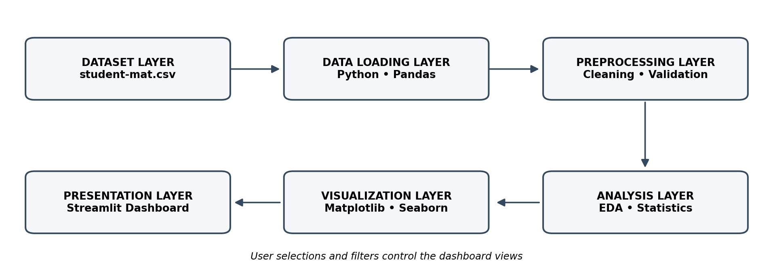
Fig. 1. Architecture of the Student Performance Analysis System.
The architecture separates data preparation from visualization so that the same prepared dataset can support multiple analytical views. The user interacts with the Streamlit dashboard and selects available filters or charts. The interface requests relevant summaries from the prepared data and presents the resulting visualizations. Unlike a live institutional information system, the current implementation uses a static CSV dataset and does not retrieve records automatically from a student information system.
V. RESULTS AND DISCUSSION
A. Dataset Inspection
The dashboard workflow enables the user to inspect the loaded dataset, review its dimensions, view sample records, and examine column-level information. These checks help confirm that the expected file has been loaded and that the selected attributes are available for subsequent analysis. The mathematics dataset is structured around student records and includes both academic grades and contextual attributes.
B. Grade Distribution
The analysis of G1, G2, and G3 provides a view of student marks across the three assessment periods. Distribution plots can show whether grades are concentrated in particular ranges and whether the final-grade distribution differs from earlier periods. These charts support descriptive comparison. Exact numerical findings, such as grade averages and category counts, must be taken from the actual dashboard execution on the project dataset rather than estimated.
C. Attribute-wise Comparison
Grouping records by selected attributes, such as study time, past class failures, school support, or family support, allows the dashboard to compare observed grade summaries across groups. Such comparisons can help users identify patterns worth further investigation. Differences between groups should be interpreted cautiously because the dataset is observational and does not control for all possible influences.
D. Relationships Among Numeric Variables
A correlation heatmap can be used to inspect linear associations among numerical attributes such as G1, G2, G3, absences, age, and study time. The relationship among G1, G2, and G3 is especially relevant because earlier-period grades are closely related to the final grade in this dataset [3], [20]. Correlation values should be interpreted as associations, not evidence of causation.
- Dashboard Output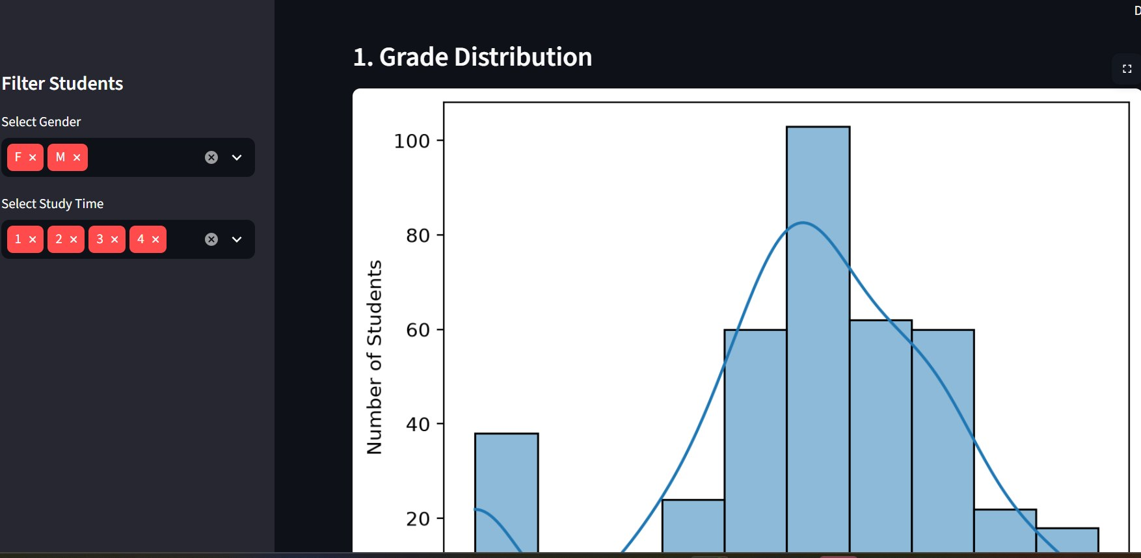
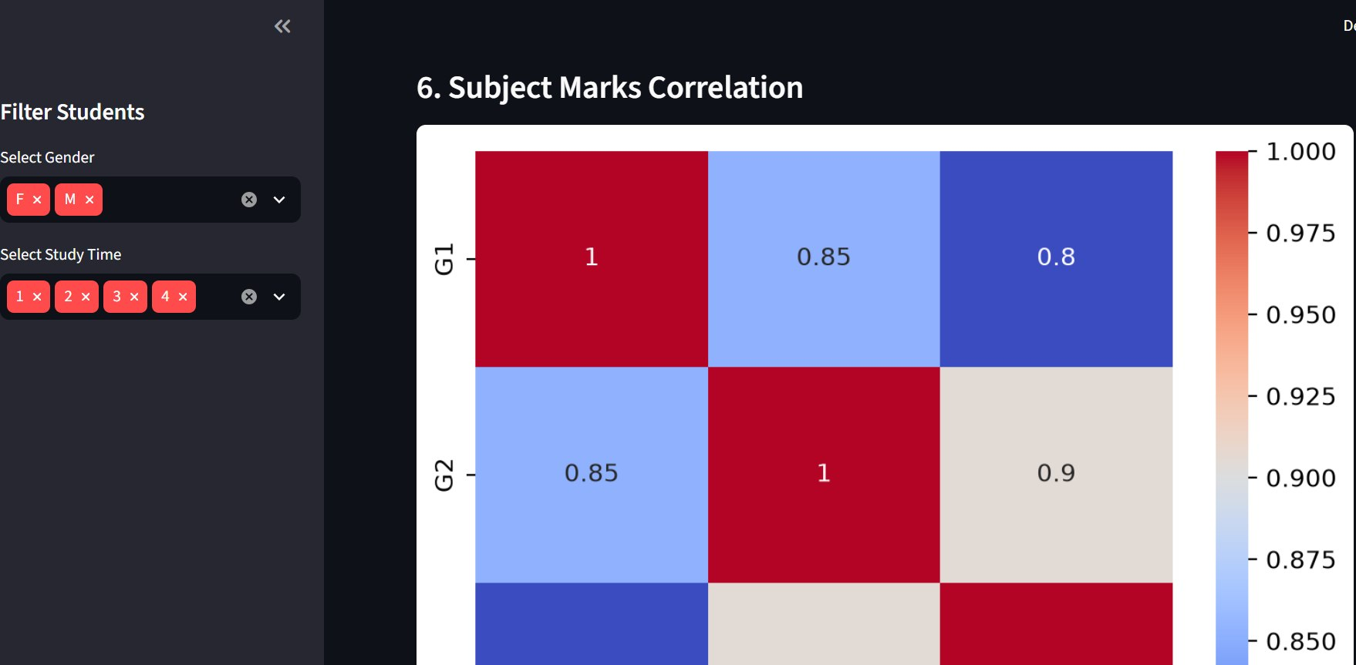
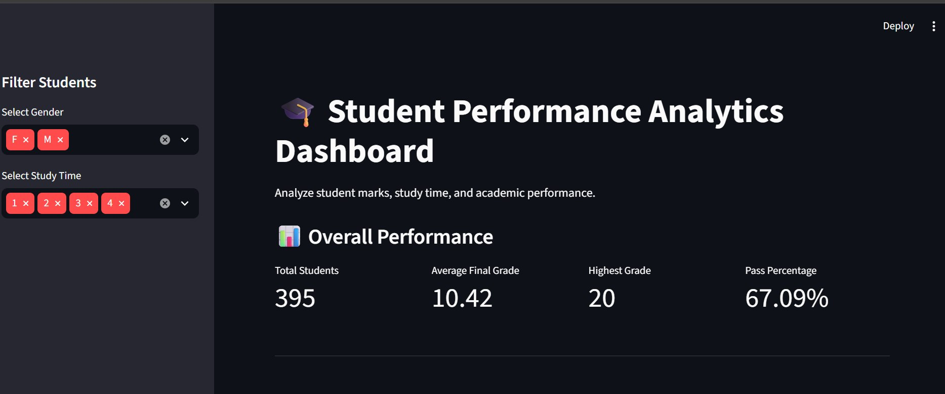
The Streamlit interface brings the analytical outputs together in one place. It allows a user to navigate available summaries and visualizations and inspect selected aspects of student performance. This reduces the need to manually create separate charts from the CSV file. The dashboard is intended as a decision-support and learning tool, not as a replacement for teacher judgement or formal student evaluation.
Note for final submission: insert screenshots of the running Streamlit dashboard in this section and report the exact values displayed by the current implementation. Do not use estimated or invented accuracy scores, averages, or conclusions. Only describe filters and charts that are present in the running application.
VI. LIMITATIONS
The project uses a single historical mathematics dataset from Portuguese secondary schools. Therefore, its findings may not generalize to other subjects, institutions, regions, or current student populations. The dataset contains a limited number of records and may not include all factors that influence academic achievement.
Some attributes are categorical or ordinal and must be interpreted using the dataset documentation. Self-reported or coded responses may not capture the full context of student behaviour. Missingness and data quality should be checked before interpreting summaries.
The current system focuses on exploratory analysis and visualization. It does not establish causal relationships, diagnose individual learning difficulties, or predict future academic outcomes. Any future predictive model would require a clearly defined target, suitable train-test separation, evaluation metrics, and checks for data leakage. Using G1 and G2 to predict G3 should be distinguished from predicting final performance before earlier assessments are available.
VII. CONCLUSION AND FUTURE SCOPE
This paper presented a Student Performance Analysis System that uses Python-based data processing and visualization to explore academic records. The system loads the student-mat.csv dataset, inspects and prepares the data, performs exploratory analysis, and presents charts and summaries through a Streamlit dashboard. By bringing grade distributions and selected student attributes into a common interface, the project makes it easier to explore academic patterns than working with an unprocessed spreadsheet alone.
Future work can extend the system by supporting additional subjects and institution-specific datasets, adding attendance and semester-wise records, and improving the dashboard with downloadable reports and role-based access. A carefully validated machine-learning module may also be added to estimate performance or identify students who may benefit from support. Such an extension should use appropriate validation, explainable results, privacy safeguards, and regular evaluation before being used in real academic decisions.
ACKNOWLEDGMENT
The authors thank Dr. N. Sunanda and the Department of Computer Science and Engineering, KL University, Bachupally, for academic guidance and support. The authors also acknowledge the creators of the Student Performance dataset and the UCI Machine Learning Repository for making the dataset available for research and educational use.
REFERENCES
[1] C. Romero and S. Ventura, “Educational data mining: A review of the state of the art,” IEEE Trans. Syst., Man, Cybern. C, vol. 40, no. 6, pp. 601–618, 2010, doi: 10.1109/TSMCC.2010.2053532.
[2] R. S. Baker and K. Yacef, “The state of educational data mining in 2009: A review and future visions,” J. Educ. Data Mining, vol. 1, no. 1, pp. 3–17, 2009.
[3] P. Cortez and A. M. G. Silva, “Using data mining to predict secondary school student performance,” in Proc. 5th Future Business Technology Conf. (FUBUTEC), Porto, Portugal, 2008, pp. 5–12.
[4] R. Asif, A. Merceron, S. A. Ali, and N. G. Haider, “Analyzing undergraduate students’ performance using educational data mining,” Comput. Educ., vol. 113, pp. 177–194, 2017, doi: 10.1016/j.compedu.2017.05.007.
[5] A. Abu Saa, M. Al-Emran, and K. Shaalan, “Factors affecting students’ performance in higher education: A systematic review of predictive data mining techniques,” Technol. Knowl. Learn., vol. 24, no. 4, pp. 567–598, 2019, doi: 10.1007/s10758-019-09408-7.
[6] E. Alyahyan and D. Düştegör, “Predicting academic success in higher education: Literature review and best practices,” Int. J. Educ. Technol. High. Educ., vol. 17, Art. no. 3, 2020, doi: 10.1186/s41239-020-0177-7.
[7] A. Namoun and A. Alshanqiti, “Predicting student performance using data mining and learning analytics techniques: A systematic literature review,” Appl. Sci., vol. 11, no. 1, Art. no. 237, 2021, doi: 10.3390/app11010237.
[8] A. Khan and S. K. Ghosh, “Student performance analysis and prediction in classroom learning: A review of educational data mining studies,” Educ. Inf. Technol., vol. 26, no. 1, pp. 205–240, 2021, doi: 10.1007/s10639-020-10230-3.
[9] Y. Zhang, Y. Yun, R. An, J. Cui, H. Dai, and X. Shang, “Educational data mining techniques for student performance prediction: Method review and comparison analysis,” Front. Psychol., vol. 12, Art. no. 698490, 2021, doi: 10.3389/fpsyg.2021.698490.
[10] J. López-Zambrano, J. A. Lara Torralbo, and C. Romero, “Early prediction of student learning performance through data mining: A systematic review,” Psicothema, vol. 33, no. 3, pp. 456–465, 2021, doi: 10.7334/psicothema2021.62.
[11] M. Hussain, W. Zhu, W. Zhang, and S. M. R. Abidi, “Student engagement predictions in an e-learning system and their impact on student course assessment scores,” Comput. Intell. Neurosci., vol. 2018, Art. no. 6347186, 2018, doi: 10.1155/2018/6347186.
[12] M. H. Bin Roslan and C. J. Chen, “Educational data mining for student performance prediction: A systematic literature review (2015–2021),” Int. J. Emerg. Technol. Learn., vol. 17, no. 5, pp. 147–179, 2022, doi: 10.3991/ijet.v17i05.27685.
[13] M. Yağcı, “Educational data mining: Prediction of students’ academic performance using machine learning algorithms,” Smart Learn. Environ., vol. 9, Art. no. 11, 2022, doi: 10.1186/s40561-022-00192-z.
[14] C. Chaka, “Educational data mining, student academic performance prediction, prediction methods, algorithms and tools: An overview of reviews,” J. e-Learn. Knowl. Soc., 2022, doi: 10.20368/1971-8829/1135578.
[15] A. Alwarthan et al., “Predicting student academic performance at higher education using data mining: A systematic review,” Appl. Comput. Intell. Soft Comput., vol. 2022, Art. no. 8924028, 2022, doi: 10.1155/2022/8924028.
[16] Y. Altujjar, W. Altamimi, I. Al-Turaiki, and M. Al-Razgan, “Predicting critical courses affecting students performance: A case study,” Procedia Comput. Sci., vol. 82, pp. 65–71, 2016, doi: 10.1016/j.procs.2016.04.010.
[17] C. Romero, M.-I. López, J.-M. Luna, and S. Ventura, “Predicting students’ final performance from participation in on-line discussion forums,” Comput. Educ., vol. 68, pp. 458–472, 2013, doi: 10.1016/j.compedu.2013.06.009.
[18] R. M. Santos and R. Henriques, “Accurate, timely, and portable: Course-agnostic early prediction of student performance from LMS logs,” Comput. Educ.: Artif. Intell., vol. 4, Art. no. 100175, 2023, doi: 10.1016/j.caeai.2023.100175.
[19] D. Khairy, N. Alharbi, M. A. Amasha, M. F. Areed, S. Alkhalaf, and R. A. Abougalala, “Prediction of student exam performance using data mining classification algorithms,” Educ. Inf. Technol., vol. 29, pp. 21621–21645, 2024, doi: 10.1007/s10639-024-12619-w.
[20] UCI Machine Learning Repository, “Student Performance,” 2014. [Online]. Available: https://archive.ics.uci.edu/dataset/320/student+performance. Accessed: Nov. 5, 2026.

